The Efficacy of Bag Limit Regulations in California Recreational Fisheries
Thomas. R. Carruthers¹, Laura Ryley² & Julia Coates³

1. Director, Blue Matter Science Ltd., tom@bluematterscience.com, 2150 Bridgman Ave, N. Vancouver, B.C. Canada V7P 2T9 (corresponding author)
2. Senior Environmental Scientist (Specialist), California Department of Fish and Wildlife,
julia.coates@wildlife.ca.gov, 1933 Cliff Dr #9, Santa Barbara, CA, United States of America
93109
3. Senior Environmental Scientist (Supervisory), California Department of Fish and Wildlife,
laura.ryley@wildlife.ca.gov, 20 Lower Ragsdale Dr Suite 100, Monterey, CA, United States of
America 93940

Keywords
Simulation, management strategy evaluation, Halibut, Black Rockfish, fishery regulations, size limit.
Abstract

Previous evaluations of alternative bag limits have been retrospective and have estimated the historical release of fish had a bag limit been in place. These approaches do not provide predictions of bag limit efficacy at varying stock sizes in conjunction with other management regulations. We developed statistical models that predict release rate based on a given bag limit and catch rate. These ‘bag limit models’ were fitted to logbook data for recreational fisheries of California Halibut and Black Rockfish in northern California. Models were selected for each fishery that assumed a log-normal distribution of trip-level catch rates with a constant background rate of releases. The selected bag limit models are a new, previously unavailable tool, allowing investigation of bag limit management procedures in management strategy evaluation (MSE) to evaluate performance against other regulations such as effort control and size limits. Operating models were specified from recent stock assessments for both species and used to conduct projections to test the efficacy of various management options. Simulations indicate that the current suite of regulations are unlikely to lead to overexploitation of Halibut and Black Rockfish. Simulation projections revealed that bag limits alone are unlikely to provide protection against overexploitation, particularly when stock sizes are low, and may incur more costly trade-offs to achieve conservation benefits comparable with other regulations.
1. Introduction
Bag limit regulations (also known as ‘retention limits’, ‘possession limits’ and ‘harvest limits’) are used widely in the management of freshwater and marine recreational fisheries throughout North America (e.g., Anon 2024, CDFW 2024, DFO 2024, FFWCC 2024, Government of British Columbia 2024) and globally, for example in Australia (Government of Tasmania 2024, Government of Western Australia 2024) and New Zealand (New Zealand Government 2024). Expressed as a maximum number of fish that can be retained on a daily trip for an individual angler, a bag limit prescribes a maximum retainable catch rate. It follows that bag limits are most likely to restrict the catch of more skilled fishers and those operating in times or locations of relatively high abundance. For a given level of fishing effort, the ability of bag limits to control fishery exploitation depends on post-release mortality of discarded fish, and angler behaviors such as the continued targeting of species after a bag limit has been met, and high-grading (staying within a bag limit by releasing smaller fish in favor of larger fish that are caught subsequently). A constant bag limit can be expected to limit fishery exploitation most strongly when catch rates are high (supported by large stocks) and post-release mortality is negligible. When they are effective, bag limits can be seen as a hybrid of an output control (catches) and an input control (fishing effort).

The efficacy of bag limits as a tool in fisheries management has not been investigated as thoroughly as other regulations such as minimum size limits (Homans and Ruliffson 1999; Moreau & Matthias 2018), gear restrictions (Carvalho and Humphries 2022, Graham et al. 2007, Renren et al. 2022) and spatio-temporal closures to fishing (Chagaris et al. 2019, Hilborn et al. 2004, Lester et al., 2009, Poulton et al. 2023). Most studies of bag limits have focused on economic theory (e.g., Woodward and Griffin 2003; Scrogin et al. 2004) and compliance (e.g., Wilberg 2009, Holzer and McConnell 2017). Those studies implementing population dynamics models have used relatively simple frameworks (e.g., Porch and Fox 1990, Cox et. al. 2002, Powell et al. 2010, Tetzlaff et al. 2013). Current decision support tools for bag limit regulations are limited to simple arithmetic approaches such as The U.S. National Oceanic and Atmospheric Administration’s bag limit calculator (NOAA 2022). Such tools do not examine the interaction between bag limits and other management policies, they do not account for feedback with stock dynamics, or allow for the investigation of dynamic regulations that respond to updated fishery data. Fisheries managers are increasingly applying Management Strategy Evaluation (MSE) for testing Management Procedures (MPs) - algorithms that adjust management recommendations in response to data. Most MPs set catch and effort limits rather than adjusting regulations such as bag limits (Punt et al. 2016, Carruthers et al. 2019). There is a need for a theoretical approach to predict the impact of alternative bag limit policies within the operating models of an MSE.

In California, bag limits and minimum size limits were among the first laws impacting recreational fishing in the 1940s (Allen et al. 2006). The initial motivation behind imposing bag limits was to minimize fish wastage in situations where anglers retained more than they could use (Miller and Gotshall 1964). Since then, both single species and multi-species bag limits have been implemented widely in California recreational fisheries but the biological underpinnings and expected management outcomes remain understudied. To investigate the efficacy of bag limits as implemented in California, we focused on California Halibut (Paralychthys californicus) and Black Rockfish (Sebastes melanops) fisheries which had sufficient data to specify defensible population and fishery dynamics but had contrasting habitat, commercial value and desirability for recreational anglers. Additionally, both species have undergone recent stock assessments. Stock assessments provide an underlying population dynamics model that can be used as an operating model within an MSE to generate simulated population dynamics. Halibut was of particular interest because the California Department of Fish and Wildlife (CDFW) is currently undergoing a review of Halibut management including stakeholder engagement, stock assessment, bycatch evaluation, and upcoming MSE. The recreational sector is responsible for a large proportion of total Halibut catch and since bag limits are an existing regulation, future MSE requires an approach to approximate the impact of bag limits on the fishery as part of a candidate management procedure.

California Halibut are managed under the authority of the California Fish and Game Commission. A minimum size limit and bag limit were both implemented as the first regulations on recreational Halibut in 1971. Bag limits of 3 and 5 fish in northern and southern areas (see Figure 1) respectively, were imposed until 2023 when the northern limit was reduced to two fish under an ‘emergency’, temporary rule change. The change was initially prompted by the concern that a salmon fishery closure and groundfish restrictions might shift an unsustainable amount of angling effort to Halibut. The new limit became permanent in June 2024 and there is a need to anticipate its future impact in the northern area.

Black Rockfish have been subject to a different management authority whereby the Pacific Fishery Management Council (PFMC) sets annual catch limits based on stock assessments conducted by the National Marine Fisheries Service. The PFMC and CDFW then worked together to implement restrictions for both the commercial and recreational sectors. In September 2025, Black Rockfish in California were among several nearshore species approved for removal from the federal Pacific Coast Groundfish Fishery Management Plan by action of the PFMC, beginning a regulatory process to transfer Black Rockfish to state management authority exclusively. As annual catch limits have fluctuated, bag limits have also changed and the use of multiple different bag limits within recent history concurrent with available data on recreational fishing provided an opportunity to contrast catch and release rates under different conditions. Initially, limits were implemented as a multispecies limit of 10 fish per angler per day that combined all rockfish, cabezon and greenling (2000 - 2014). From 2015 onwards, a sub-bag limit of 5 Black Rockfish per day was implemented within the 10 fish per day multispecies limit. That was further reduced to 3 Black Rockfish per day starting in 2017 until 2019 when it was increased to 4 fish per day on June 1, 2019. The Black Rockfish sub-bag limit was removed again for the 2021 season onwards. These changes, in conjunction with season and depth limit adjustments, have successfully maintained Black Rockfish within federally set harvest limits.

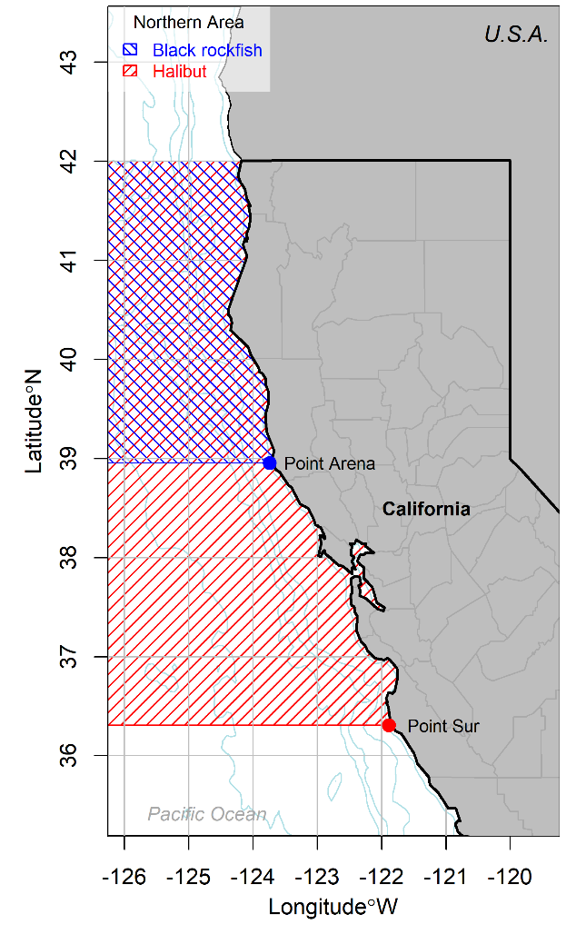
Figure 1. The study area, located in Northern California, U.S.A. The northern area for Black Rockfish stock assessment (blue) and for Halibut bag limit regulations (red) extend from the northern border of California to Point Arena and Point Sur in the south, respectively.

The role of current bag limits, relative to these other measures, in achieving management objectives relating to conservation, access and exploitation requires evaluation. In this research we aim to develop theoretical models that predict the impact of bag limit regulations on recreational fishery exploitation, fit these models to empirical data, and then incorporate the models in a MSE simulation framework to allow for comparative performance evaluation with alternative management approaches. We addressed the following research questions. (1) Do the trip-level data suggest that bag limits are consequential for the management of Halibut and Black Rockfish? (2) Can theoretical models be developed that approximate the impact of bag limits on fishery exploitation rates? (3) Are bag limits likely to be an effective management measure for species such as Halibut and Black Rockfish? (4) How do bag limits compare to other management regulations in terms of their expected management outcomes?

2. Methods

2.1. Data

Recreational party/charter vessels are licensed by CDFW to take paying passengers on sport fishing trips and are also commonly known as commercial passenger fishing vessels (CPFVs). The owner of the boat is required by law to submit records of fishing activity in logbooks (i.e., logs). CDFW is required to keep all license and fishing activity records confidential but may compile or publish summaries that do not disclose individual or business information (Fish and Game Code, section 8022(a)). Logs are submitted for each fishing trip (or each day of fishing for multi-day trips) and collect information including but not limited to the vessel identification number, date of fishing, port of landing, target species, fishing method, hours fished, number of fishers, and number of fish kept and released by species.

Ports were used to assign catches to the northern and southern areas. For Halibut these are defined as those trips originating from ports north/south of Point Sur which divides regions subject to different bag limits. The Black Rockfish division is higher in latitude at Point Arena reflecting the boundary used for the stock assessment model (Figure 1). For both species, it was assumed that boats did not traverse management areas. Mean trip-level catch rates were calculated as the sum of retained and released fish divided by the number of operators (anglers) on the vessel. This assumes that anglers may share all landed fish among their individual bag limits.

The catch rates of the northern area are generally much higher than those of the southern area for both species (Figure 2). Catch rates of Halibut are so low in the southern management area that they rarely exceeded the 5-fish bag limit and would rarely lead to hitting even very restrictive bag limits. This research focused on the data from the northern area for both stocks since those data provided the necessary contrast in catch rates required to evaluate theoretical bag limit models.

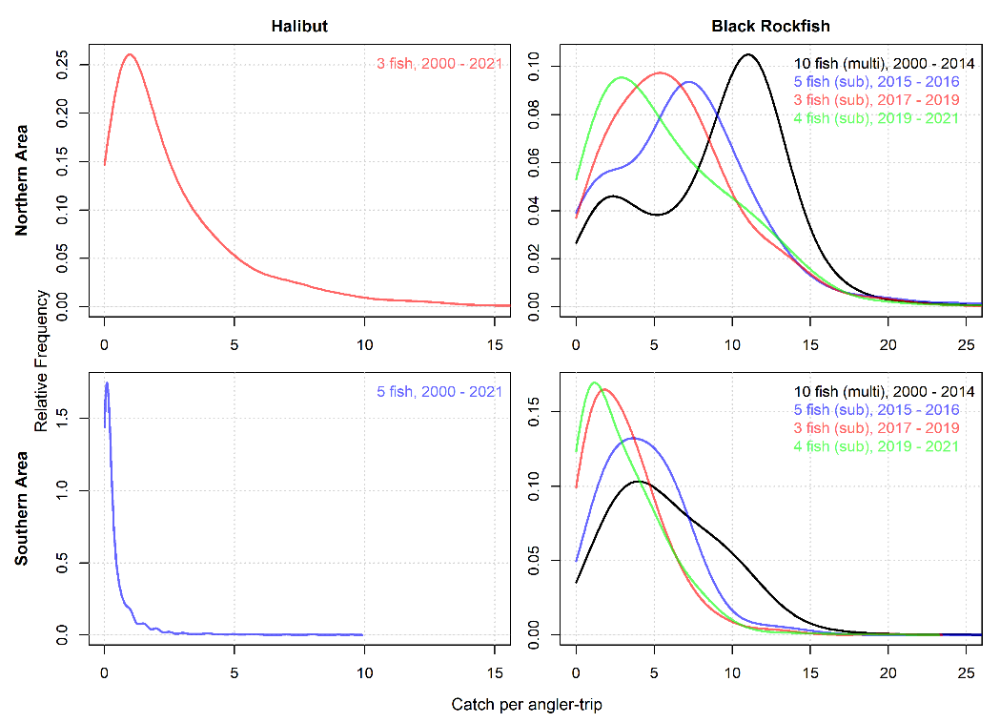
Figure 2. Distribution of trip-level catch rates among species and management areas for the last 10 historical years of logbook data (2014-2023) (y-axis scale varies among panels).

A key limitation of the logbook data used in these analyses is a lack of information about the size of retained and released fish. While there is no rockfish size limit, a 55 cm minimum size limit (22 inches in regulation) has been in place for Halibut throughout the period when logbook data were collected. Depending on whether the size limit is adhered to there may be releases of sub-legal-size fish. In the absence of trip-level data to account for discarding due to size, annual estimates of discarding of undersized fish from the Halibut stock assessment model were used to provide a downward adjustment of the observed Halibut release rates. The estimated releases due were calculated as the fraction of predicted catches by number in size classes below the minimum size limit. This was necessary in order to isolate the impact of size limits on releases such that changes in both regulations could be comparatively evaluated in simulations.

2.2. Bag Limit Models

The central methodological objective of this research was to characterize the observed relationship between trip-level catch rate (assumed to be related to vulnerable abundance) and release rate (affecting fishing mortality rate) given varying bag limit regulations, to predict the impact of existing and future bag limit regulations. Here, ‘release rate’ refers to the proportion of caught fish that were released (sometimes referred to as ‘potential catch’, Lew and Larson 2014).

Catch rate data have been characterized by a wide range of statistical distributions including the binomial, negative binomial and Poisson for discrete data, and log-normal distributions for continuous data. In this application the binomial and negative binomial distributions (e.g., Porch and Fox 1990) could not be fitted with sufficient imprecision to approximate the observed distribution of catch rates (Figure 2) and these statistical distributions were not considered further. Several bag limit models of varying flexibility based on log-normal distribution were investigated that predicted release rates from catch rates (Table 1, Figure 3). To demonstrate the challenges of modelling discrete catch rates using the Poisson distribution, two derivatives were also investigated (Table 1, Figure 3). The bag limit models included derivations that could account for background releases due to phenomena such as high-grading and voluntary releases.

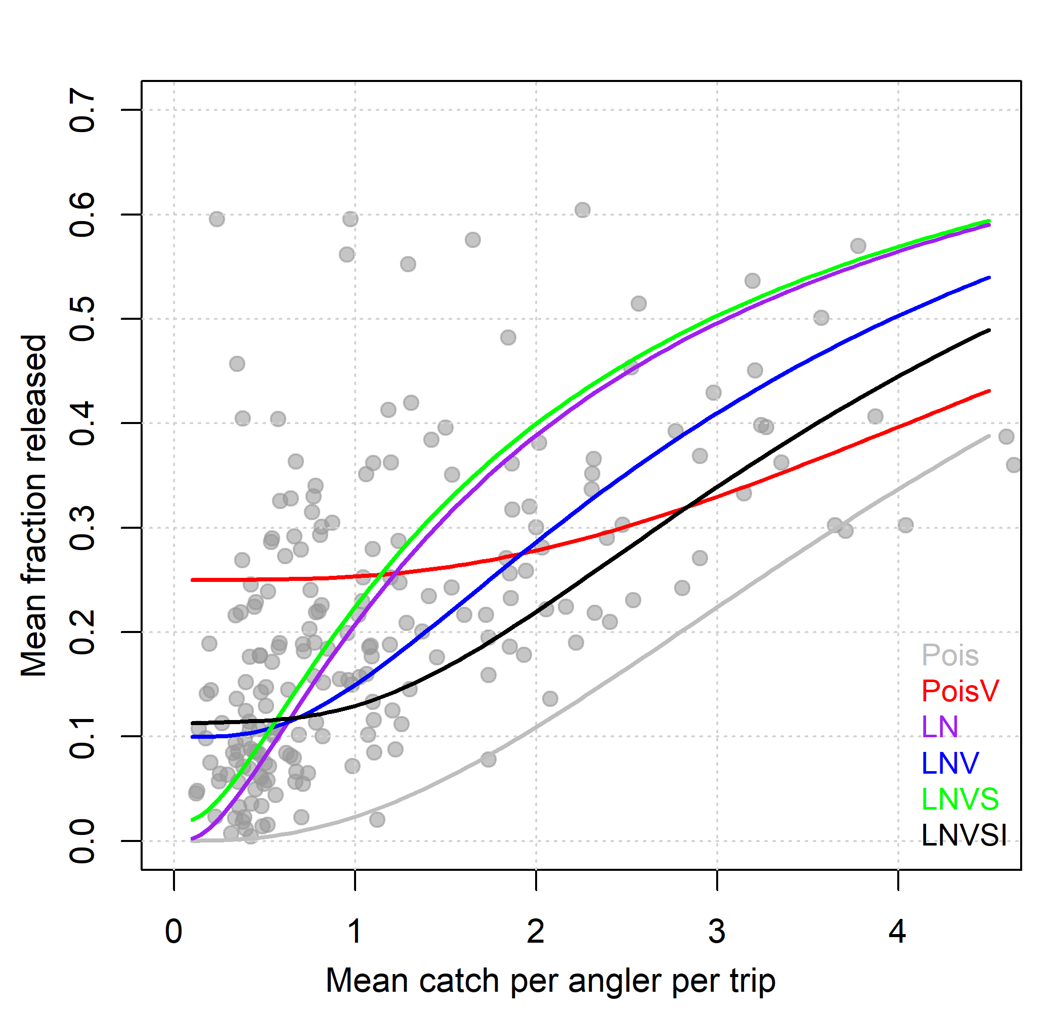
Figure 3. Preliminary exploration of statistical model types (Table 1) for Halibut data for the northern area from the logbook dataset (2016 - 2023) (bag limit of 3 fish).

Table 1. Statistical bag limit models for predicting mean release rate (across all trips) from mean catch rate (across all trips). Models include two discrete Poisson models with and without a constant background release rate (Pois and PoisV, respectively), and five continuous lognormal distributions that: (LN) do not model background release rate, (LNV) include a constant background (voluntary) release rate, (LNVS) model background release rate as a linear relationship with mean catch rate and a similar approach (LNVSI) with both intercept and slope in the relationship between background release rate and mean catch rate. Note that the fractions released (r) and retained (k) are calculated from the integral of the product of catch rate and the probability density at that catch rate. Integration was approximated numerically over a vector of catch rate values.

Model | Equation | Terms
 | $$r=1-k$$  $$k=\frac{\sum_{i=1}^{n}{d_{i}y_{i}}}{\sum_{i=1}^{n}{d_{i}c_{i}}}$$  yi=KciKci<TBTBTB≤ Kci  K=1-V | r: release rate of fish (average fraction released).  k: proportion of fish retained.  d_{i}: probability density at catch rate c_{i}.  y_{i}: predicted retained catch rate.  c_{i}: catch rate.  n: the length of the c and d vectors  i: vector position [1, 2, …, n]  T: trip limit.  .
Discrete Poisson catch rate distribution
 | $$d_{i}=\frac{\exp^{-λ}λ^{i}}{i!}$$ | λ: the mean (and assumed variance) of the observed catch rate distribution.  V₀: constant background release rate (estimated).
Pois | $$V=0$$
PoisV | $$V= V_{0}$$
Continuous lognormal catch rate distributions
 | $$d_{i}=\frac{1}{c_{i}σ\sqrt{2π}}exp\left(-\frac{{\left(\ln\left(c_{i}\right)- μ\right)}^{2}}{2σ^{2}}\right)$$ | µ: mean log catch rate.  σ: log standard deviation.  α: slope (inverse logit space) background release rate with mean catch rate (estimated).  β: intercept (inverse logit space) of background release rate with catch rate (release rate near zero fish caught) (estimated).
LN | $$V=0$$
LNV | $$V= V_{0}$$
LNVS | $$V=\exp^{αμ-4}/\left(1+\exp^{αμ-4}\right)$$
LNVSI | $$V=\exp^{αμ-β}/\left(1+\exp^{αμ-β}\right)$$

Several of the models include both releases due to the bag limit (the proportion of the predicted catch rate distribution above the bag limit) and also releases due to either a constant or variable background rate of releases. For example, LNVS assumes a log-normal distribution of catch rates and a linearly increasing rate of background releases with mean observed catch rate (Figure 4).

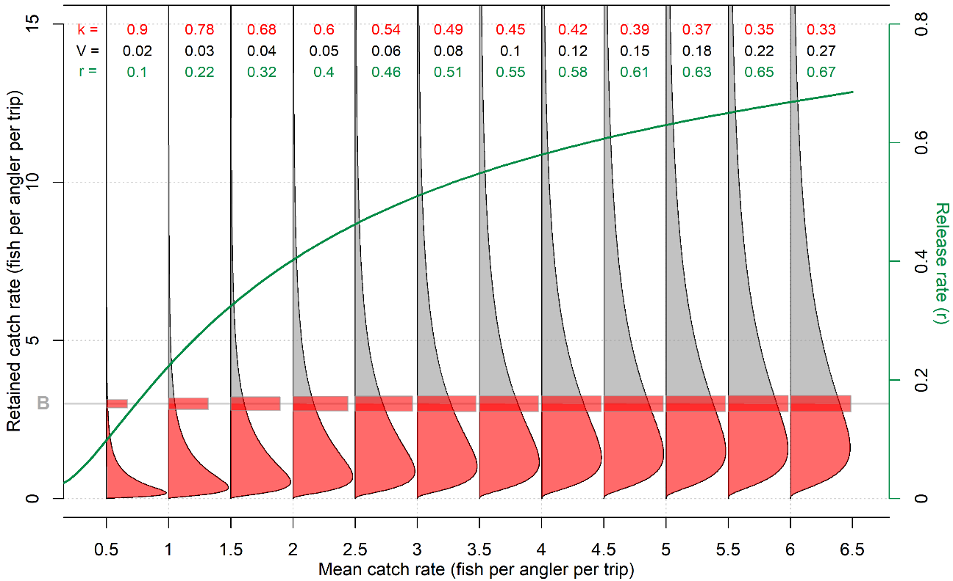
Figure 4. Components of the log-normal bag limit model LNVS that includes a (log) linearly increasing background release rate (V), the fraction of fish that are retained (k, red) and the release rate (r, green, 1-k). The lognormal distributions show the assumed distribution of trip-level catch rates after the background level of voluntary releases. The fraction of retained fish (k) is the sum of trips with retained catches below the bag limit (B) (area of the lognormal density distribution that is shaded red). For trips with retained catch rates above the bag limit (grey area), these are constrained by the bag limit and a fraction of those catches are retained (up to the bag limit) denoted by a red horizontal bar, the area of which is proportional to this fraction(see calculation of y, Table 1).

2.3. Fitting Bag Limit Models to Data

The bag limit models (Table 1) were fitted to the Halibut logbook data of the northern area to provide an initial indication of which models should be pursued more formally via statistical fitting and model selection (Figure 3). The Poisson distribution (Pois) was generally too imprecise to capture observed gradients in release rate as catch rates increased, providing predicted release rates that were consistently below those observed (Figure 3). When a background rate of releases was included (PoisV), the best-fit of the model failed to approximate the positive trend in release rates with catch rate (Figure 3). A background rate of release (V) was necessary to capture positive release rates as mean catch rates tended to zero, ruling out the lognormal model without the modelling of background releases (LN).

Based on these initial results, three types of bag limit models (LNV, LNVS, LNVSI, Table 1) were fitted to Halibut and Black Rockfish data by minimizing the negative log likelihood (assuming a logistic-normal observation error model) of observed release rate given model predicted release rate. The LNV and LNVS models are special cases of the LNVSI model for which slope (α: LNV) and intercept (β: LNV and LNVS) are fixed at the lowest values permitted by the estimation (close to zero). These fitted models were evaluated for overall fit to data according the negative loglikelihood, to identify a suitably flexible and parsimonious model for incorporation in bag limit management procedures.

2.4. Operating Models

Operating models were developed in the open-source MSE framework OpenMSE (Hordyk et al. 2025). The most recent stock assessments for northern Halibut (Coates et al. 2025) and Black Rockfish (Dick et al. 2023) were converted into OpenMSE operating models (see Figure 5 for operating model reconstruction of spawning stock biomass and fishing mortality rate). Both were age- and sex-structured Stock Synthesis (Methot and Wetzel 2013) assessments fitted to catch, relative abundance indices and length- and age- composition data with multiple recreational and commercial fleets. The historical reconstruction of the stock and fishery in the operating models exactly matched the maximum likelihood estimate of the stock assessments. The ‘Base Case’ stock assessment for Halibut estimated a very healthy stock biomass in 2020 that was above equilibrium unfished conditions (Figure 5) largely due to the estimation of a very strong 2016 year class. This assessment did not pass peer-review (Barnes et al. 2024) as a suitable basis for providing management advice for Halibut in the northern area. However, the Base Case model does accurately represent key dynamics of northern Halibut for the purposes of investigating bag limits, such as longevity, somatic growth, recruitment variability and fishery selectivity.

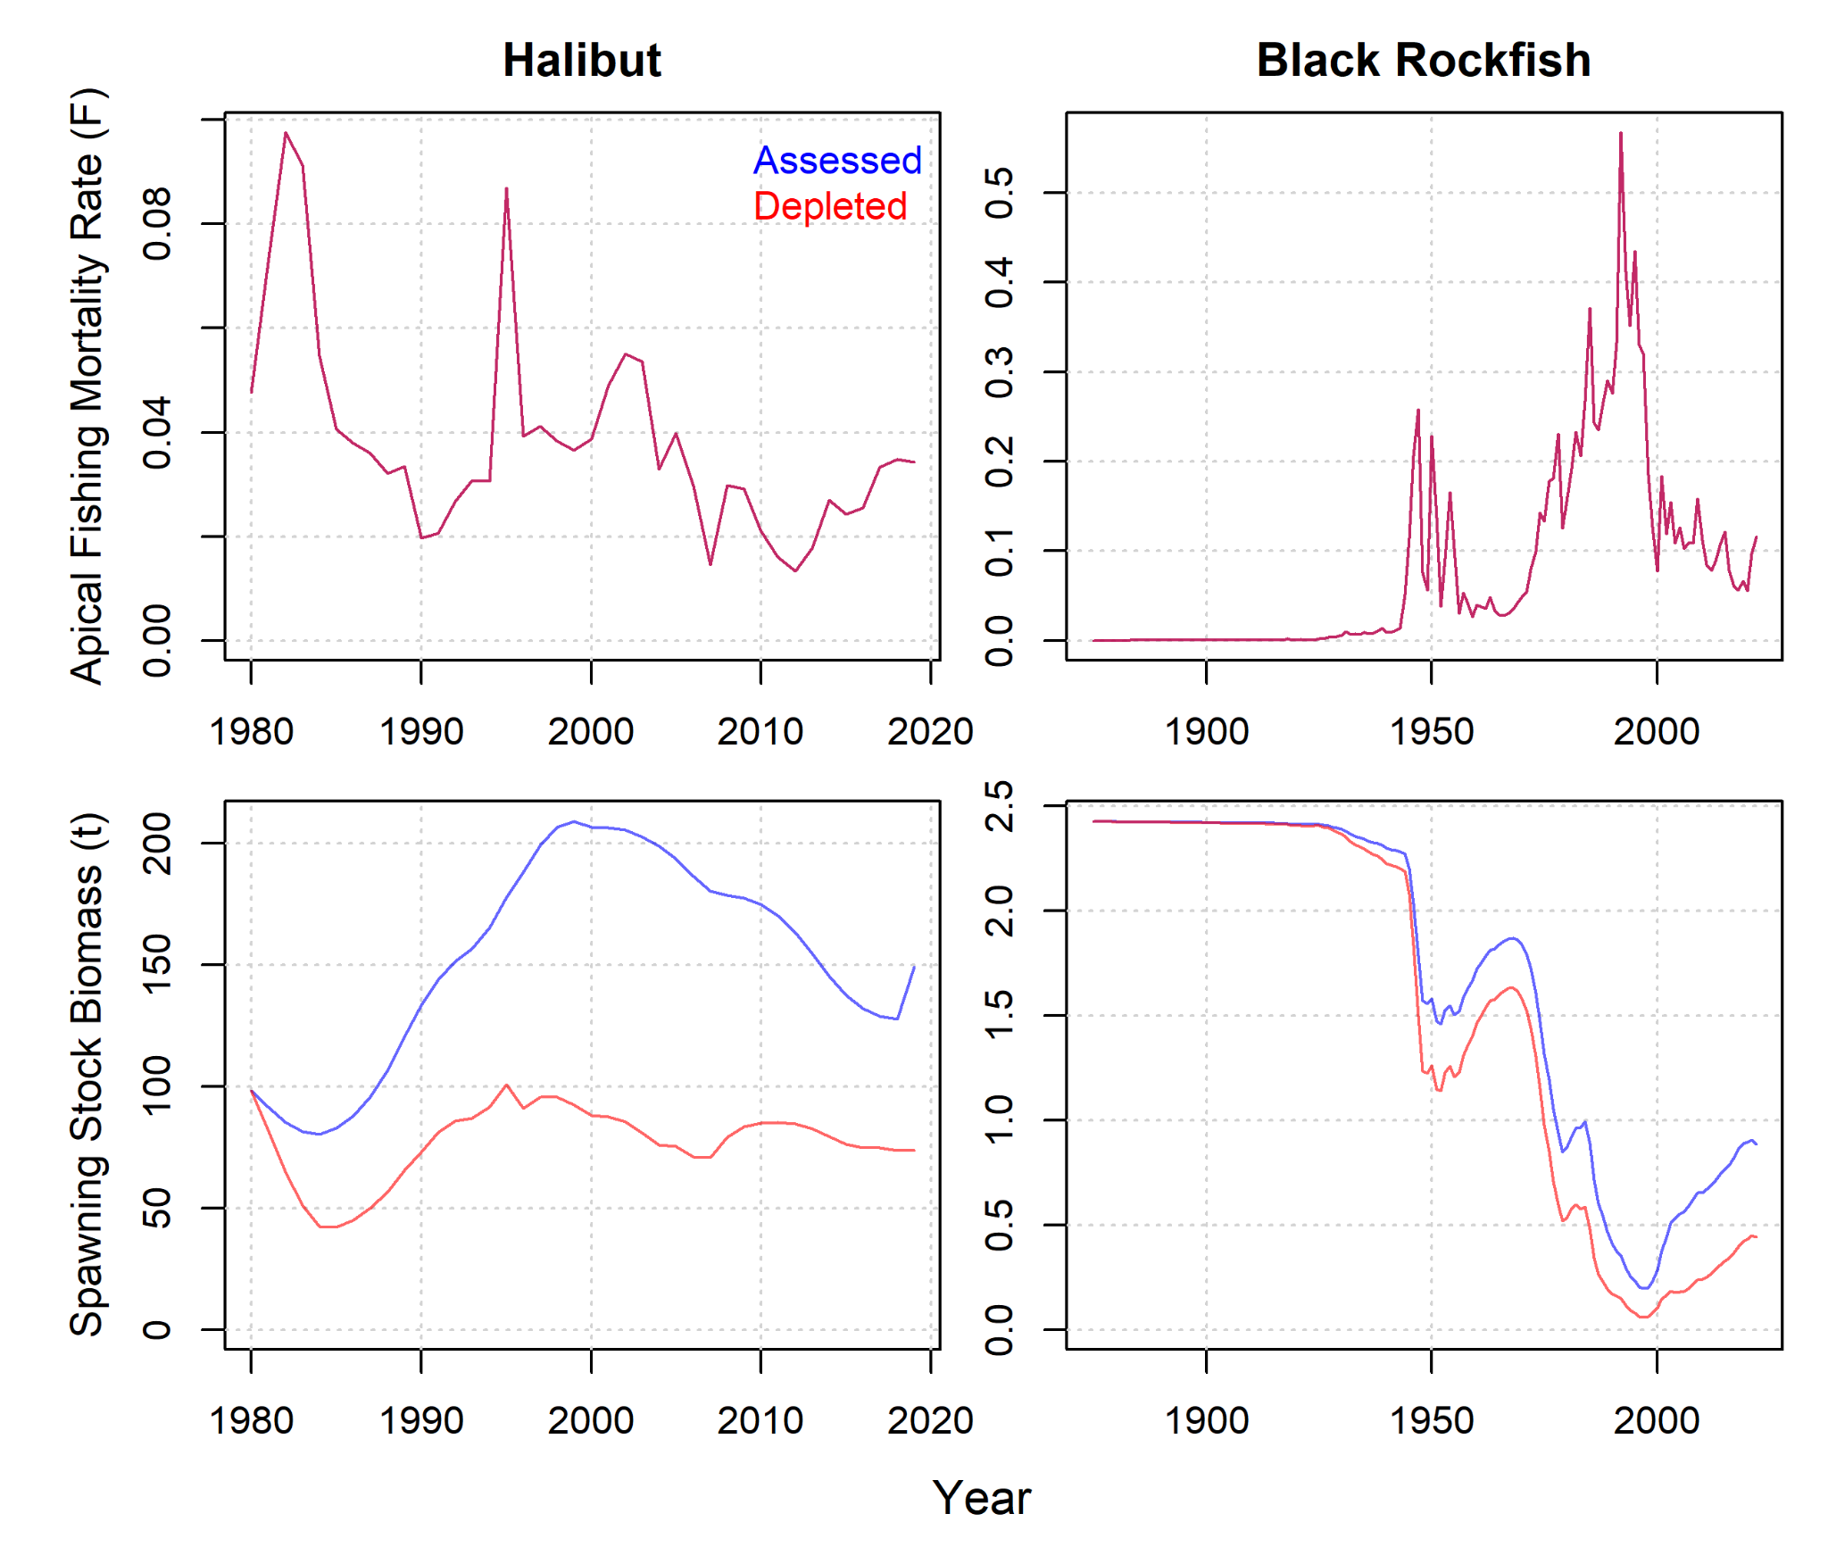
Figure 5. Maximum likelihood estimates of historical exploitation rate and spawning stock biomass for Halibut and Black Rockfish in northern California originating from stock assessments for these species. Blue lines represent the estimates of the stock assessments. Red lines represent Depleted operating models where current (2019) spawning stock biomass is half that of the ‘Base Case’ assessed level.

The Black Rockfish Base Case model, which did pass peer review, estimates current stock status to be at around the spawning biomass target level of 40% of unfished levels, approximately 150% of spawning biomass levels corresponding to maximum sustainable yield (SSBMSY) (Figure 5). For both species, alternative (Depleted) operating models were specified with identical patterns in historical exploitation but with current stock depletion half of the Base Case levels. The depletion scenarios were specified by optimizing the magnitude of estimated fishing mortality rate (the historical pattern was kept constant) required to obtain the specified stock depletion in the most recent historical year. This was done to better understand the properties of bag limit regulations at lower stock sizes where management decision making may be more critical.

2.5. Modeling Bag Limits in Closed-Loop MSE Simulations

Parameter uncertainty in the fitted LNV model was captured in the subsequent MSE simulations by sampling model parameters σ and V₀ (Table 1) from a bivariate normal distribution defined by the variance-covariance matrix (inverse Hessian) of the maximum likelihood model fit. For each MSE simulation, a pair of these model parameters were sampled.

Observed catch rates were available for the historical time period of fishing and used to calculate the constant of proportionality (catchability) with model predicted vulnerable biomass for each simulation. Using these catchabilities it was possible to pass the true simulated mean catch rate of CPFVs from the operating models to the bag limit management procedures (MPs). Those MPs used the bag limit model to predict release rates which were then passed back to the operating models for the calculation of updated exploitation rates. In addition to release rates, simulation testing required an estimate of post-release mortality rate and the fraction of overall exploitation attributable to CPFV fishing. Post-release mortality rate was assumed to be 5% for Halibut, and 20% for Black Rockfish (PFMC 2024). This rate corresponds to the PFMC mortality rate for black rockfish caught at depths between 11-20 fathoms. The PFMC mortality rate for flatfish in the federal FMP is 7%. Given that Halibut are not in the federal FMP and Meyer (2007) found a lower mortality rate of 3.5% for Pacific Halibut released in excellent condition, we assumed a rate of 5%. The current annual exploitation rate that could be attributed to CPFV fishing was calculated from catch proportions over the last 5 historical years (2019 – 2023) and was 60% for Halibut and 80% for Black Rockfish. The exploitation rate of non-CPFV fishing was then held constant for the projections.

The default MP used here for MSE projections assumed a constant fishing effort (i.e., projecting stable recent number of boat-days per year). This means that other existing management measures that impact Halibut and Black Rockfish exploitation rate (e.g. marine protected areas, depth restrictions, seasons) are implicitly modeled as unchanging. Reference points such as FMSY are affected by bag limits and other regulations such as size limits and those impacting dead discarding. We chose to frame fishing mortality in terms of the exploitation rate on the most selected age class (‘apical F’) and evaluated projected MP performance by comparing apical F with the exploitation rate on the most selected age class at FMSY (‘apical FMSY’), where FMSY was calculated from conditions at the end of the historical time period. This definition of exploitation rate relative to FMSY provided a constant reference point among MPs that could vary regulations such as minimum size limits. Alternative bag limit policies were compared with varying fishing effort for both species, size-limit regulations for Halibut and discard mortality for Black Rockfish. Size limit polices were assumed to be followed exactly and affected the retention of recreational fishing fleets in future years. Fish caught in size classes below the minimum size limit were released (zero retention) subject to post-release mortality rate.
3. Results

3.1. Empirical Evaluation of the Fraction of Fish Released Due to Reaching Bag Limits

The trip-level data were analyzed to quantify the fraction of released fish that would have been released due to the 3 fish bag limit for Halibut and the varying bag limits ranging from 3-10 fish for Black Rockfish. For trips where the total number of caught fish exceeded the bag limit, the difference was recorded and summed by year and management area. In this way the expected fraction of releases due to the bag limit regulation could be calculated directly. This analysis is similar to the retrospective bag limit decision support tools mentioned in the introduction and our purpose was to gain an intuition into the degree to which bag limits have been restrictive in the past.

Until 2014, logbook data suggest that release rates of Halibut due to the bag limit have been close to zero for most years, with occasional years where release fractions could exceed 10%. After 2015, the predicted release fractions increased to between 20 and 30% due to increases in observed catch rates (Figure 6, left hand panel). According to this empirical analysis, the reduction in bag limits for Black Rockfish could be expected to drive a large increase in predicted release rate from around 10% from 2005 – 2015) to 20 – 35% between 2015 and 2020 (Figure 6, right hand panel).

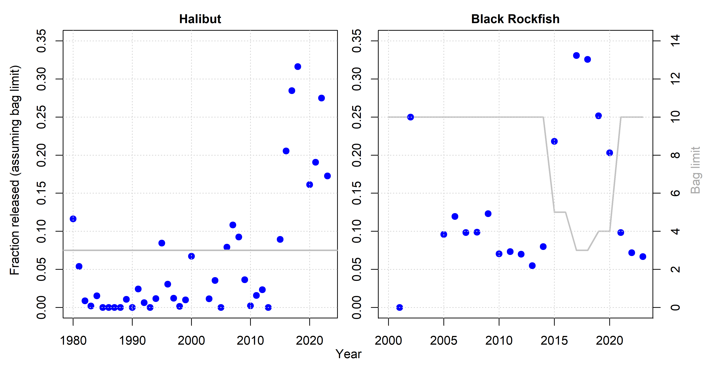
Figure 6. Empirical calculation of release rate given the specified bag limits and observed logbook catch rate. The plotted points are the fraction would have been released if the bag limit were adhered to perfectly given the historical bag limit (grey line, right axis) and the observed trip-level catch rates. Although bag limits are imposed collectively on all rockfish, cabezon and greenling species, this empirical analysis calculates releases assuming only Black Rockfish were caught.

3.2. Fitting Bag Limit Models and Selecting a Parsimonious Model

Without modelling background rate of releases, the Poisson model (Pois) and lognormal models (LN) were not able to approximate relatively high release rates that were observed for Halibut (Figure 3). Including a constant background rate of releases allowed the Poisson (PoisV) and log-normal (LNV) models to fit the observed data that had non-zero release rates at low catch rates (i.e. top row, Figure 7). However, the Poisson model exhibited too flat a trend through the mean release rate data with respect to catch rates (Figure 3). Modelling background release rates as a linear function of mean catch rate without an intercept (LNVS) could not approximate the non-zero release rates at low catch rates and was not investigated further (e.g., Figure 7, panel e). For both Halibut and Black Rockfish, adding an intercept term to this model (LNVSI) (Figure 7, bottom row) did not appreciably improve fit to the data (less than 2 negative log likelihood points) over the simplest lognormal model with constant background releases LNV, which was selected as the most parsimonious model appropriate for modelling bag limits for both Halibut and Black Rockfish (Figure 7). Although the historical bag-limit of 10 Black Rockfish also included other species, it appears to have been too high to substantially impact release rate (Figure 7). Assuming single-species dynamics when modelling historical release rates and conducting MSE projections, was supported by the relatively clear patterns in release rate as a function of catch rates (Figure 7).

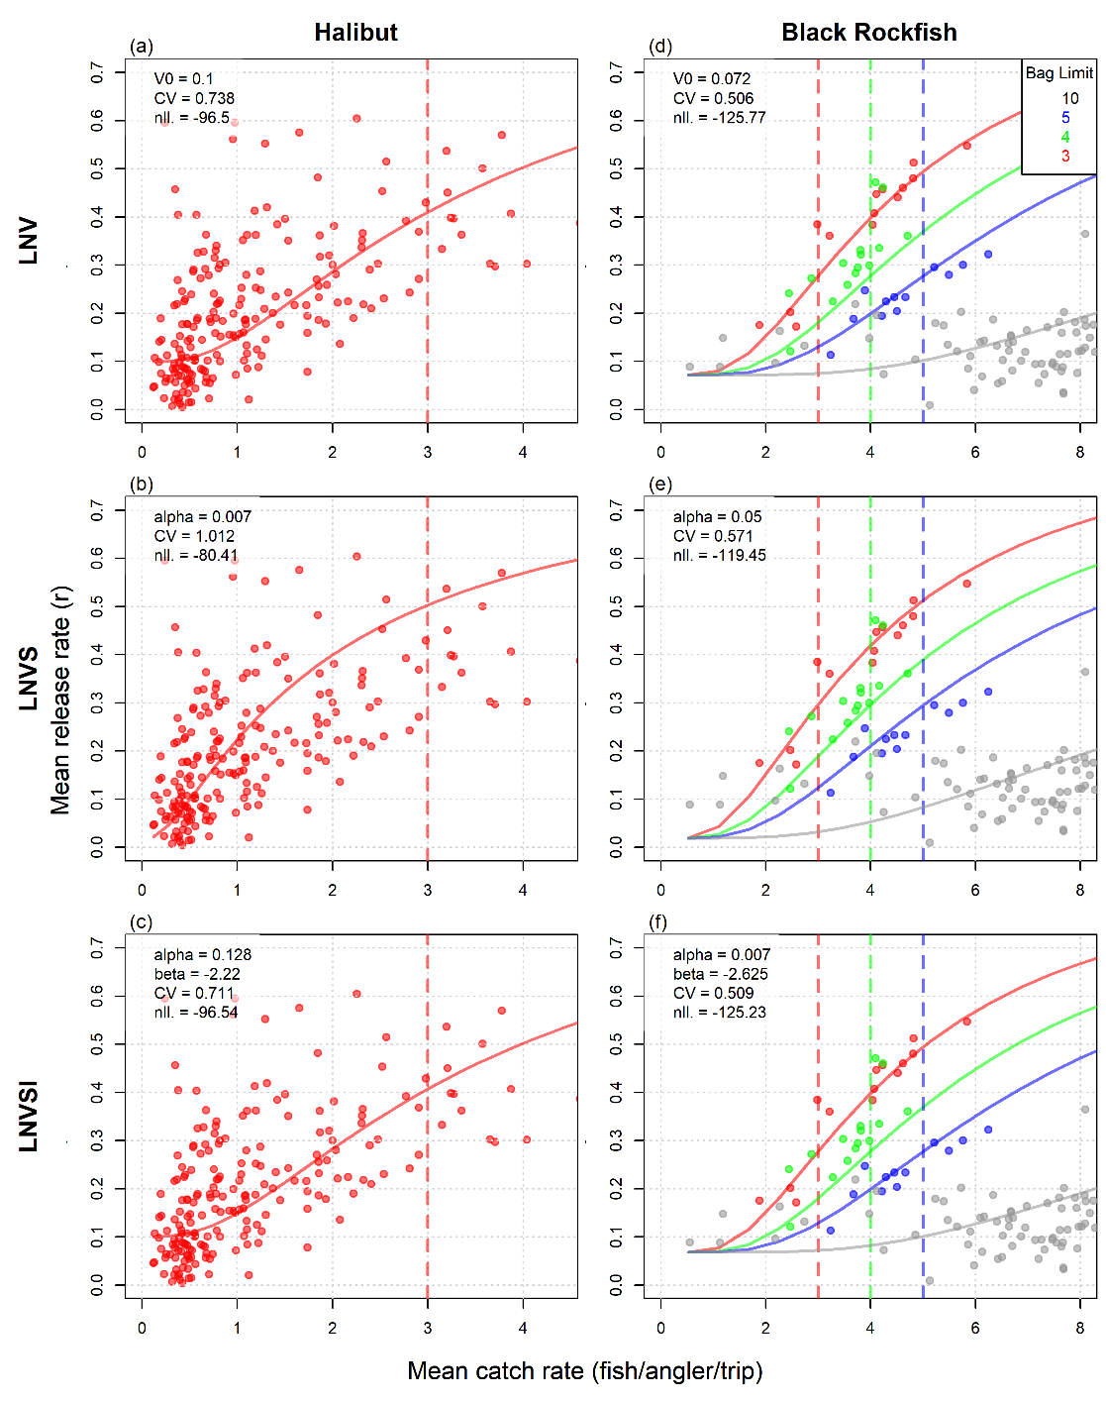
Figure 7. Model fitting results for mean catch rate and release rates of the logbook dataset. Three log-normal bag limit models (Table 2) were fitted that estimated: (LNV) a constant background release rate (parameter V0); (LNVS) a linearly increasing (inverse logit space) background release rate calculated from the slope (alpha) with mean catch rate; (LNVSI) the same model with an intercept (beta, inverse logit space). Plotted points are observed monthly mean catch rate and mean release rates from 1980 – 2023 color coded by the bag limit regulations (vertical dashed lines) in place when those data were collected. The colored lines represent the maximum likelihood fit of each bag limit model. Included in each panel are the estimated parameters including the log-normal coefficient of variation (CV) and negative log-likelihood (nll) of the model fit. Model LNV was selected for use in subsequent simulation analyses.

3.3. Simulation Results

Projections started from the maximum likelihood estimate of the assessed stock level and exploitation rate (a point value) for the last historical year (2019). Comparing projections of the same bag limit policy among Base Case and Depleted operating models revealed the role of life-history in determining the duration of transient effects of stock depletion. In the case of Halibut, recruitment variation among simulations drives a relatively rapid expansion in uncertainty in projected biomass and yield outcomes over the first 10 projected years (Figure 8). In contrast, the longer-lived Black Rockfish takes at least 20 years to develop a comparable level of yield and biomass uncertainty. After 20 projected years for Halibut and 40 projected years for Black Rockfish, the initial conditions of the projection (Base Case / Depleted) were no longer a determinant of yield and spawning biomass outcomes (Figure 8).

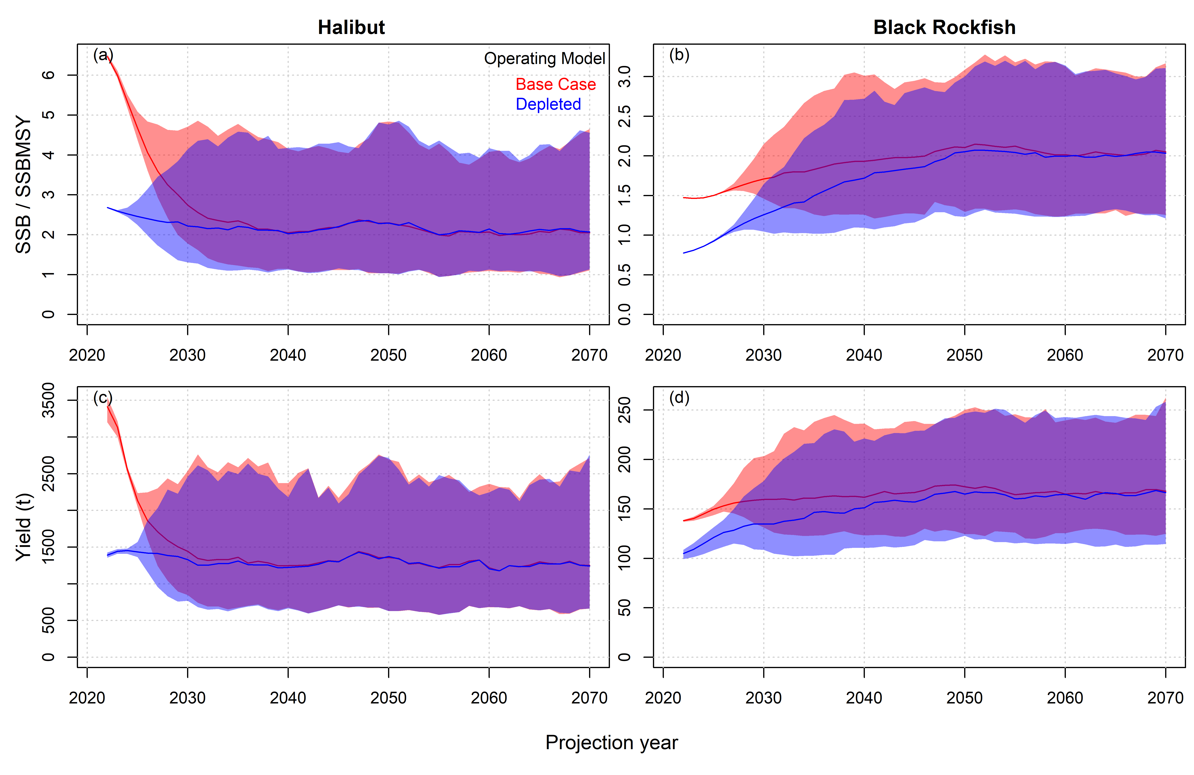
Figure 8. Projection of the bag limit management procedures with a Halibut bag limit of 3 fish and a Black Rockfish bag limit of 5 fish, for the Base Case (red) and Depleted (blue) operating models. The solid lines represent the median value over 144 simulations, the shaded regions are the 90% interquantile range. Projections show impacts after the first management cycle (2 years after the historical reconstruction).

Reducing the Halibut bag limit to 2 fish from 4 fish, led to reduction in yield of about 10% and an increase in stock level (SSB relative to SSBMSY) of about 15% (Figure 9, panels c and a, respectively). The role of natural variability in determining outcomes was relatively high leading to distributions of yield and biomass outcomes that overlapped strongly. The lower bag limit of 2 fish did not impact the lower tail of yield outcomes, with the less restrictive 4-fish bag limit only providing larger potential yields in the most productive simulations (Figure 9, panel c).

Reducing the Black Rockfish bag limit from 10 to 5 fish led to 35% declines in yield and a 20% increase in SSB relative to SSBMSY levels (Figure 9, panels d and b, respectively). Natural variability in stock levels played a lesser role in the case of Black Rockfish with yield and biomass outcomes that still heavily overlapped but were more distinct among bag limit regulations compared with Halibut.

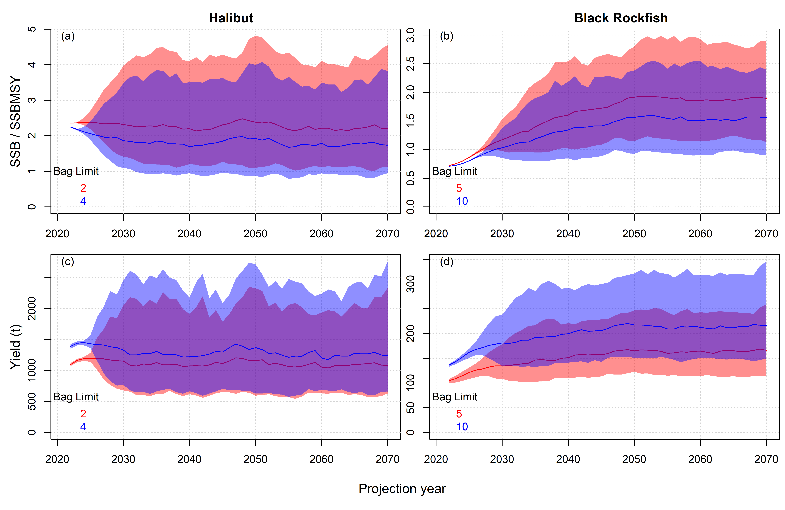
Figure 9. As Figure 8, comparing projections of spawning stock biomass and yield given alternative bag limits for the Depleted operating models.

The trade-off between long-term expected yields and biomass is negative and nearly linear for both Halibut and Black Rockfish (Figure 10). In the case of Halibut, 320 tons of annual catch is traded off against a unit of SSB / SSBMSY (Figure 10, panel b, grey line). For Black Rockfish, 135 tons of annual catch is traded off against a unit of SSB / SSBMSY (Figure 10, panel b, grey line).

Relatively modest changes to effort controls (80% - 120% of apical FMSY effort) provided a comparable range of performance outcomes to a wide range of Halibut bag limits (1-6 fish) (Figure 10, panel a). Effort controls also provided a slightly superior performance trade-off with respect to Halibut biomass and yields, with less steep yield changes across the same range of biomass outcomes. To a greater extent, effort control was more effective (relative to bag limits) in the case of Black Rockfish, providing much lower yield reductions across a comparable range of biomass outcomes. For example, a 30% reduction in effort (Figure 10, panel b, blue line) was comparable in biomass outcomes to a reduction in bag limit from 10 to 4 fish (Figure 10, panel b, grey line) and provided 27% higher yields on average.

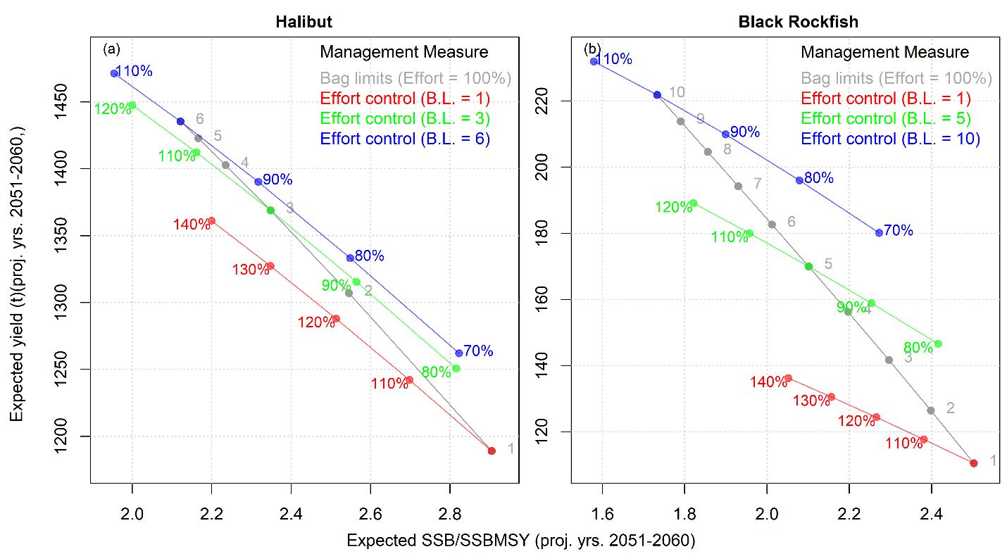
Figure 10. The impact of bag limits and effort control on the long-term (2051-2060) mean spawning biomass relative to MSY levels, and mean fishery yields. The performance trade-off is presented for various bag limit levels given 100% apical FMSY fishing (grey) and varying percentages of apical FMSY fishing given low, medium and high bag limits (red, green and blue, respectively). Simulations (n=144) were carried out for the ‘Depleted’ operating models.

Varying the Halibut size limit from 45 cm to 65 cm suggested that the current regulation of 55 cm corresponds approximately to maximum yield given apical FMSY fishing (Figure 11, panel a). Increasing the minimum size limit to 60 cm provided better biomass conservation for a relatively small loss (4%) in long-term expected yield. This trade-off was somewhat steeper when increasing the minimum size limit to 65 cm. Reducing the size limit below 50 cm reduces both long-term yield and biomass regardless of bag limit regulation (Figure 11, panel a).

Varying post-release mortality rates of Black Rockfish reveals a positive performance trade-off between yields and biomass outcomes whereby both higher biomass and yields are obtained by reductions in post-release mortality (Figure 11, panel b).

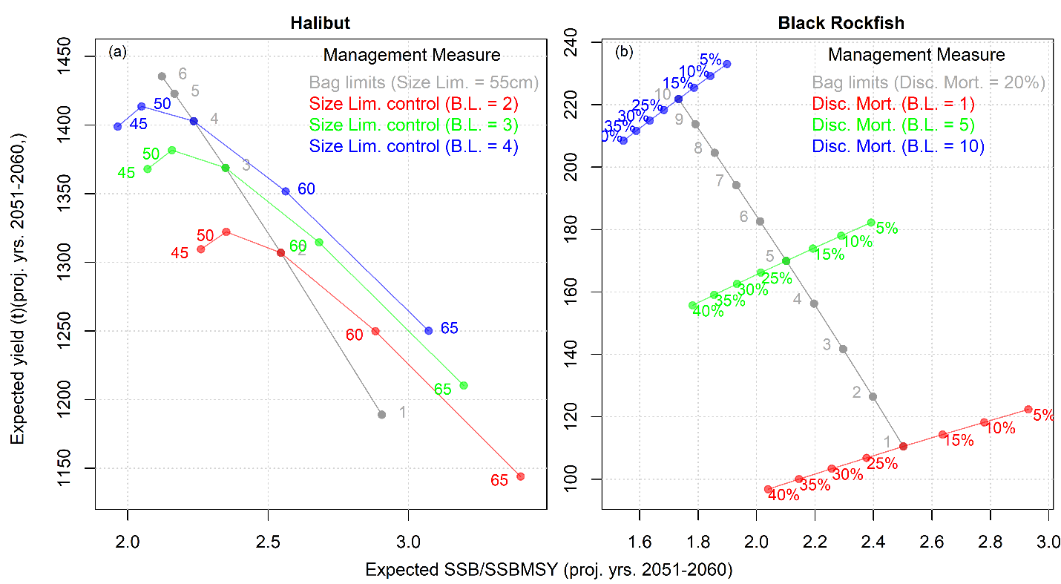
Figure 11. The long-term performance impacts of bag limits relative to Halibut minimum size limits and Black Rockfish discard mortality rate. Panel a shows long-term biomass and yield performance outcomes for Halibut across bag limits of 1 - 6 (with the 55cm minimum size limit, grey) and minimum size limits from 45cm to 65cm. Panel b compares Black Rockfish bag limits of 1-10 with changes in discard mortality rate from 5% to 45%. Simulations (n=144) were carried out for the ‘Depleted’ operating models.

Plotting the projected spawning biomass and fishing mortality rate outcomes for each simulation over projection years illustrates the behavior of the bag limit regulation in controlling fishing mortality rate with varying stock level (Figure 12). For both species and regardless of the bag limit specified, bag limit regulations provided a pattern of fishery exploitation control that contrasts the harvest control rules typically specified for managing stocks, that are either constant exploitation rates or have lower exploitation rates at lower stock sizes (Figure 12) (i.e., bag limits result in high exploitation rate at low stock sizes because anglers do not hit the limits when stock size is low).

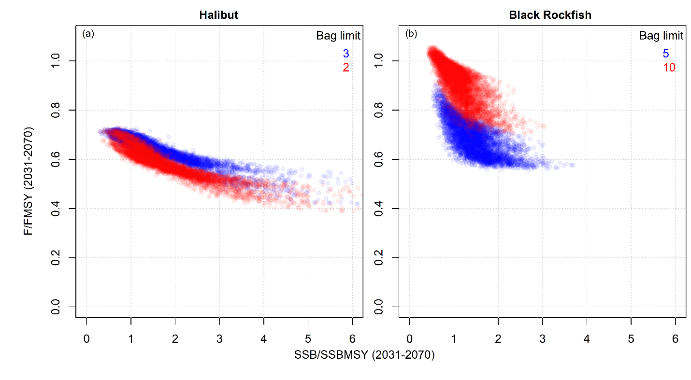
Figure 12. Implied harvest control rule of Halibut and Black Rockfish bag limits. Halibut bag limit of 2 and 3 fish and Black Rockfish bag limits of 5 and 10 fish were projected for the Depleted operating model. Projections assumed 150% apical FMSY fishing effort to reveal the relationships between projected spawning biomass and the fishing mortality rate arising from the bag limit. The higher exploitation rate was required to obtain simulations with biomass below MSY levels.

4. Discussion
This research developed the first bag limit management procedure for use in MSE that captures uncertainty in model fit to data. The bag limit MPs were tested in MSEs based on operating models derived from recent stock assessments, comparing against other regulations such as effort control and minimum size limits to reveal management performance trade-offs. This work established a novel methodology that can be used to strategically inform a wider range of fishery regulations for many potential recreational fisheries. In California, a general limit on recreationally caught finfish limits anglers to 20 fish in combination and no more than 10 of any one species unless otherwise specified (Cal. Code Regs. Tit. 14, § 27.60). In addition to this general limit, there are currently 59 rules that further restrict bag sizes for additional species or species groups including 42 that apply to finfish and 17 to invertebrates. This highlights the many opportunities in California alone for improved analysis of bag limit efficacy relative to and in combination with other management measures. MSE processes are underway for several of these California fisheries as well as various other U.S. fisheries that employ recreational bag limits including South Atlantic Snapper and Grouper (SAFMC 2025) and Dolphinfish (NOAA 2025).

A key finding of this study is that bag limits are unlikely to strongly constrain fishery exploitation rate at low stock sizes. This finding is consistent with previous studies finding bag limits to be ineffectual in limiting exploitation (Cox et al. 2002, van Poorten et al. 2013, Ochwada-Doyle et al. 2023), unable to maintain stocks at high densities (Beard et al. 2003) and potentially compromised by dead discarding (Tetzlaff et al. 2013). While most data-rich assessed fisheries in the U.S. have established harvest control rules that more strongly constrain exploitation at low stock sizes (e.g. the 40:10 rule, Berger et al. 2017, Punt and Ralston 2006), bag limits operate in the opposite way by limiting exploitation at high stock sizes and allowing for higher exploitation rates at low stock sizes. In this research, this property meant that to obtain the same conservation outcome (i.e. SSB/SSBMSY) as other regulations such as size limits and effort controls, bag limits incur a more punitive trade-off with yield. A possible solution is to establish dynamic bag limits that are increasingly restrictive as stocks decline. An extension of our work should test dynamic bag limit management procedures to see if these can achieve more consistent control of exploitation as stock size varies and improved trade-offs between yield and conservation objectives.

For the Halibut and Black Rockfish stocks, regulating fishing effort provided a more desirable trade-off among long-term yield and conservation outcomes. However, this was much more pronounced for Black Rockfish with larger reductions in yield required by bag limits to obtain the same conservation benefits as effort control. Assuming constant fishing efficiency, a constant effort policy provides a consistent exploitation level, throttling catches in proportion to stock size. This behavior contrasting with the more biologically risky behavior of bag limits described above and further underlines that bag limit regulations should not be viewed as a guard against chronic overexploitation, particularly in cases where the stock is already considered to be subject to overfishing. Fortunately, while not arising from dynamic modeling of bag limits, CDFW managers have historically understood this dynamic. Black Rockfish are within a multi-species rockfish complex that is managed with rules applying to the complex as a whole. Managers have applied season and depth restrictions when larger reductions in catch are needed, with the understanding that these rules impact the complex as a whole and can needlessly reduce catches of healthier stocks. Sub-bag limits have been applied when minor adjustments to catch are needed and can be applied to specific species within the complex. Clear separation in the catch and release rate relationships for Black Rockfish in the historical data under various bag limits (Figure 7) illustrates that these adjustments have have been impactful given sufficient stock abundance. The visibility of these patterns in the CPFV logbook data also illustrates the high quality of the data set.

Projections of Halibut operating models for the northern management area suggest that current Halibut regulations (bag limit of 2 fish, 55 cm minimum size limit) are unlikely to lead to stock depletion below BMSY levels. Comparative evaluation of current and alternative minimum size limits for Halibut suggests that the current minimum size of 55 cm corresponds with approximately maximum yield at intermediate biological risk. In addition to typical axes of uncertainty such as stock resilience, natural mortality rate and future recruitment strength, additional aspects relevant to the bag limit model should be included in robustness testing of a future Halibut MSE such as post-release mortality rate and the fraction of overall exploitation by the recreational sector.

To estimate the parameters of the bag limit model developed in this research (and implement it in an MP) requires sufficient contrast between catch rate and release rate data. This may limit its utility in investigating depleted fisheries. The Halibut and Black Rockfish data for their respective southern management areas showed low catch rates and hence limited contrast between catch rate and release rate. For this reason, it was not possible to develop useful bag limit models for the southern areas. The logbook data for Halibut in the south suggested that the current bag limit of 5 fish would have been triggered in only a very small fraction of trips (less than 1%). Reaching bag limits in the southern management area is particularly rare due to the prevalence of CPFVs in the region and the allowance for vessels to share bags among all anglers onboard. Many vessels carry over 50 passengers leading to a very high number of fish that could be shared among passengers. Research also suggests that the southern stock is more depleted and therefore even matching the northern bag limit of 2 fish is unlikely to limit fishing this region. For this reason, the analysis of bag limits for the southern management area was less practicable.

Various complexities of recreational fisheries may complicate use of the models developed in this research. For example, anecdotal evidence from operators of recreational fisheries in the U.S. Atlantic suggest that vessels can exhibit complex switching behavior among primary and secondary target species as bag limits are reached. Additionally, a substantial fraction of recreational vessels in the South Atlantic have, in essence, vessel-specific keep limits due to the size of refrigerated storage available onboard. For example, snapper fishing operators in Florida state that once they have reached refrigerated capacity, they may return to port, placing an overall catch limit by volume of all species combined. In a recreational fishery in New Jersey, Trudeau et al. (2022) found that overall effort was determined by catch rates across multiple species which might lessen the impact of single species bag limits on exploitation rate. The degree to which anglers are able to avoid a species after its bag limit is reached will impact the effectiveness of the limit. Additionally, there may be a degree of high-grading (as larger fish are caught smaller fish are thrown back dead or with high post release mortality). The models investigated here do not explicitly account for high-grading although bag limit models were investigated that could include increasing background release rate with mean catch rate which may in part account for high-grading phenomena. An extension of this work should investigate multispecies logbook data to examine patterns in catch rates that may be consistent with switching behaviors. In principle it is possible to extend these methods to multidimensional probability distributions across multiple stocks to better approximate the dynamics of multi-species bag limits.

The bag limit models of this research were fitted to data which, in the case of Black Rockfish included contrast in historical bag limits. However, angler behavior is notoriously complex and unpredictable (Fulton et al. 2011, Abbott and Fenichel 2013), and caution should be taken in the interpretation of simulation results beyond the historical range of regulations, particularly when evaluated in conjunction with changes in other management measures such as size limits. Ideally, models should be developed from experiments that better reveal angler behavior across a wide range of candidate regulations. Management performance was represented simplistically in this research focusing only on long-term biomass and yield outcomes. However, in many recreational management settings, angler satisfaction is of primary importance and this may be directly affected by regulations such as bag limits and size limits (Powell et al. 2010, Young et al. 2020) and therefore may be reflected in performance evaluations in future MSEs.

The results of this work suggest that although bag limits can be used to successfully constrain fishery exploitation at some stock sizes, they may not provide safe guards against chronic over exploitation and compared with other regulatory measures may entail larger reductions in yields to obtain comparable conservation outcomes. However, we acknowledge that implementing and enforcing effort limits is often considerably harder in recreational fisheries than commercial fisheries. With these analyses, managers can now weigh the added benefit of effort limits against costs of implementation. Given the economic, sociological and ecological importance of recreational fisheries (Cooke and Cowx, 2004, Coleman et al. 2004) it is vital that rigorous and transparent decision frameworks are available to inform management decision making. This research developed an approach for the theoretical testing of candidate bag limits as a step towards a more comprehensive strategic approach to regulation of recreational fisheries.
Code and Data

The trip-level data used in the fitting of bag limit models are confidential. However, derived code and objects such as openMSE operating models, bag limit management procedures and simulation outputs are all publicly available from a GitHub repository: https://github.com/Blue-Matter/CDFW_Bag_Limits. A concise code example of the MSE analyses is available from the project page: https://blue-matter.github.io/CaliBL

Acknowledgements

This research was supported by the Resources Legacy Fund (FIS 17037). Thanks to Huff McGonigal for supporting this work. Many thanks to Adrian Hordyk and Quang Huynh for assistance implementing methods in the OpenMSE framework. Thanks to Helen Killeen, John Budrick and Melanie Parker for their helpful comments on an earlier draft of this paper.

References
Abbott, J. K., and Fenichel, E. P. 2013. Anticipating adaptation: a mechanistic approach for linking policy and stock status to recreational angler behavior. Canadian Journal of Fisheries and Aquatic Sciences, 70: 1190–1208.
Anon 2024. Ontario fishing regulations summary. Ontario Fish and Wildlife. Available from: ontario.ca/fishingregulations [accessed Oct 2025]
Allen, L.G., D.J. Pondella, and M. H. Horn (eds.). 2006. The Ecology of Marine Fishes: California and Adjacent Waters, University of California Press, Berkeley, 670 pp.
Barnes, C., Oken, K., Sampson, D., Wetzel, C. 2024. 2024 California Halibut Stock Assessment Review Panel Report. Available from: https://mlmamasterplan.com/wp-content/uploads/2025/03/CAHalibut_STAR_Report2024_v2.pdf [accessed April 2026]
Beard, T. D., S. P. Cox, and S. R. Carpenter. 2003. Impacts of daily bag limit reductions on angler effort in Wisconsin Walleye lakes. North American Journal of Fisheries Management 23: 1283–1293. https://doi.org/10.1577/M01-227AM
Berger, A. M., Grandin, C. J., Taylor, I. G., Edwards, A. M., and Cox, S. (2017). Status of the Pacific Hake (whiting) stock in U.S. and Canadian waters in 2017. Silver Spring, MD: National Marine Fisheries Service and Fisheries and Oceans Canada.
Budrick, J., Dorn, M., Chen, Y., Powers, J. 2023. Black Rockfish Stock Assessment Review (STAR) Panel Report. Available from: https://www.pcouncil.org/documents/2023/11/stock-assessment-review-star-panel-report-for-black-Rockfish.pdf/ [accessed Oct 2025]
Carruthers, T.R., Kell, L.T., Butterworth, D.S., Maunder, M.N., Geromont, H.F., Walters, C., McAllister, M.K., Hillary, R., Levontin, P., Kitikado, T., Davies, C. 2016. Performance review of simple management procedures. ICES Journal of Marine Science. 73(2): 464-482.
Carvalho, P.G. and Humphries, A. 2022. Gear restrictions create conservation and fisheries trade-offs for management. Fish and Fisheries. 23(1): 183-194. Doi: https://doi.org/10.1111/faf.12607
CDFW 2020. 2020 California Halibut Stock Assessment, Executive Summary. California Department of Fish and Wildlife. Available from: https://nrm.dfg.ca.gov/FileHandler.ashx?DocumentID=193616&inline [accessed Oct 2025]
CDFW 2024. Ocean sport fishing regulations. California Department of Fish and Wildlife. Available from: https://wildlife.ca.gov/Fishing/Ocean [accessed Oct 2025]
Chagaris D., Allen M., and Camp E. 2019. Modeling temporal closures in a multispecies recreational fishery reveals tradeoffs associated with species seasonality and angler effort dynamics. Fish. Res. 210: 106–120.
Coates, J., Hicks, A., Valero, J., Meyer, K. 2025. The Status of California Halibut (Paralichthys californicus) in U.S. Waters, off Southern California in 2023. California Department of Fish and Wildlife. Available from: https://nrm.dfg.ca.gov/FileHandler.ashx?DocumentID=229693&inline [accessed April 2026]
Coleman F.C., Figueira W.F., Ueland J.S., and Crowder L.B. 2004. The impact of United States recreational fisheries on marine fish populations. Science, 305: 1958–1960.
Cooke, S.J., Cowx, I.G. 2004. The Role of Recreational Fishing in Global Fish Crises BioScience, 54 (9): 857-859.
Cox, S. P., T. D. Beard, and C. Walters. 2002. Harvest control in open-access sport fisheries: hot rod or asleep at the reel? Bulletin of Marine Science 70: 749–761.
Dick, E.J., C. Barnes, J. Coates, N. Grunloh, M. Monk, and T. Rogers. 2023. The Status of Black Rockfish in U.S. Waters off California in 2023. Pacific Fishery Management Council, Portland, OR. Available from http://www.pcouncil.org/groundfish/stock-assessments/
DFO 2024. Recreational fishing limits, openings and closures in British Columbia. Canadian Department Fisheries and Oceans. https://www.pac.dfo-mpo.gc.ca/fm-gp/rec/bc-zones-cb-eng.html [accessed Oct 2025]
FFWCC 2024. General Statewide Bag and Length Limits. Florida Fish and Wildlife Conservation Commission. Available from: https://myfwc.com/fishing/freshwater/regulations/general/ [accessed Oct 2025]
Fulton E.A., Smith A.D.M., Smith D.C., and Putten I.E.V. 2011. Human behaviour: the key source of uncertainty in fisheries management. Fish Fish. 12: 2–17.
Government of Tasmania 2024. Bag and size limits. Fishing Tasmania. Available from: https://fishing.tas.gov.au/recreational-fishing/rules/size-and-bag limits [accessed Oct 2025]
Government of Western Australia 2024. Recreational fishing rules. Department of Primary Industries and Regional Development. Available from: https://www.fish.wa.gov.au/FISHING-AND-AQUACULTURE/RECREATIONAL-FISHING/RECREATIONAL-FISHING-RULES/Pages/default.aspx [accessed Oct 2025]
Graham, N., Ferro, R.S.T., Karp, W.A., MacMullen, P. 2007. Fishing practice, gear design, and the ecosystem approach—three case studies demonstrating the effect of management strategy on gear selectivity and discards. ICES Journal of Marine Science. 64(4): 744–750, https://doi.org/10.1093/icesjms/fsm059
Hilborn, T., Stokes, K., Maguire, J.J., Smith, T., Botsford, L.W., Mangel, M., Orensanz, J., Parma, A., Rice, J., Bell, J., Cochrane, K.L., Garcia, S., Hall, S.J., Kirkwood, G.P., Sainsbury, K., Stefansson, G., Walters, C. 2004. When can marine reserved improve fisheries management. Ocean and Coastal Management. 47(3-4): 197-205.
Holzer, J., and K. McConnell. 2017. “Risk Preferences and Compliance in Recreational Fisheries.” Journal of the Association of Environmental and Resource Economists 4 (S1): S1–35.
Hordyk, A.R., Huynh, Q.C., Carruthers, T.R. 2025. OpenMSE: open source software for conducting fisheries management strategy evaluation. Available from: www.openMSE.com. [Accessed Oct 2025]
Lester S., Halpern B., Grorud-Colvert K., Lubchenco J., Ruttenberg B., Gaines S., et al. 2009. Biological effects within no-take marine reserves: a global synthesis. Mar. Ecol. Prog. Ser. 384: 33–46. DOI: https://doi.org/10.3354/meps08029
Lew, D. K., and D. M. Larson. 2014. “Is a Fish in Hand Worth Two in the Sea? Evidence from a Stated Preference Study.” Fisheries Research 157:124–35.
Miller, D.J., and D. Gotshall. 1965. Ocean sportfish catch and effort from Oregon to Point Arguello, California. Calif. Fish Game, Fish Bull. 130.
Methot, R.D., and Wetzel, C.R. 2013. Stock synthesis: A biological and statistical framework for fish stock assessment and fishery management. Fisheries Research 142:86–99. doi:10.1016/j.fishres.2012.10.012.
Meyer, S. 2007. Discussion Paper: Halibut Discard Mortality in Recreational Fisheries in IPHC Areas 2C and 3A. Alaska Department of Fish and Game, Division of Sport Fish. Homer, Alaska. September 17, 2007. https://www.adfg.alaska.gov/static/home/library/pdfs/sportfish/HalibutDiscards907.pdf
Moreau, C.M. & Matthias, B.G., 2018. Using limited data to identify optimal bag and size limits to prevent overfishing. North American Journal of Fisheries Management. 38 (3): 747-758.
New Zealand Government. 2024. Central area fishing rules. Available from: https://www.mpi.govt.nz/fishing-aquaculture/recreational-fishing/fishing-rules/central-fishing-rules/ [accessed Oct 2025].
NOAA. 2022. Bag limit analysis. U.S. National Oceanic and Atmospheric Administration. Available from: https://www.st.nmfs.noaa.gov/st1/recreational/pubs/data_users/chap_7.pdf [accessed Oct 2025]
NOAA. 2025. Dolphinfish Management Strategy Evaluation in the U.S. Atlantic. Available from: https://www.fisheries.noaa.gov/southeast/science-data/dolphinfish-management-strategy-evaluation-us-atlantic [accessed Oct 2025]
Ochwada-Doyle, F., Hughes, J., Fowler, A.M., Murphy, J., Stark, K., Lowry, M., West, L., Taylor, M.D. 2023. Quantifying the potential impact of reducing recreational harvest limits on the catch of a key marine species using off-site angler survey data, ICES Journal of Marine Science. 80(2): 295–307, https://doi.org/10.1093/icesjms/fsac232

PFMC. 2024. Status of the Pacific Coast Groundfish Fishery, Stock Assessment and Fishery Evaluation, Description of the Fishery. The Pacific Fishery Management Council. Portland, OR. August 2024. pcouncil.org/documents/2024/08/status-of-the-pacific-coast-groundfish-fishery-stock-assessment-and-fishery-evaluation-july-2025.pdf/
Porch, C.E., Fox, W.W. 1990. Simulating the dynamical trends of fisheries regulated by small daily bag limits. Transactions of the American Fisheries Society. 119(5): 836-849. https://doi.org/10.1577/1548-8659(1990)119<0836:STDTOF>2.3.CO;2
Poulton, A.J., Sethi, S.A., Ellner, S.P., and Smeltz, T.S. 2023. Optimal dynamic spatial closures can improve fishery yield and reduce fishing-induced habitat damage. Canadian Journal of Fisheries and Aquatic Sciences. 80(6): 893-912. https://doi.org/10.1139/cjfas-2022-0198
Powell E.N., Bochenek E.A., and DePersenaire J. 2010. Evaluation of bag-and-size-limit options in the management of summer flounder Paralichthys dentatus. Fish. Res. 105: 215–227.
Punt, A. & Ralston, S. 2007. A Management Strategy Evaluation of Rebuilding Revision Rules for Overfished Rockfish Stocks. Biology, Assessment and Management of North Pacific Rockfishes. Alaska Sea Grant College Program. 10.4027/bamnpr.2007.19.
Punt, A.E., Butterworth, D.S., de Moor, C.L., De Oliveira, J.A.A. & Haddon, M. 2016. Management strategy evaluation: best practices. Fish and Fisheries, 17, 303–334, http://dx.doi.org/10.1111/faf.12104.
Rehren, J., Coll, M., Jiddawi, N., , Kluger, L.C., Omar, O., Christensen, V., Pennino, G.M., Wolff, M. 2022. Evaluating ecosystem impacts of gear regulations in a data-limited fishery—comparing approaches to estimate predator–prey interactions in Ecopath with Ecosim, ICES Journal of Marine Science. 79(5): 1624–1636, https://doi.org/10.1093/icesjms/fsac077
SAFMC. 2024. Management Strategy Evaluation for the South Atlantic Snapper-Grouper Fisheries. South Atlantic Fisheries Management Council. Available from: https://safmc-mse.bluematterscience.com/ [accessed Oct 2025]
Scrogin, D., K. Boyle, G. Parsons, and A. J. Plantinga. 2004. “Effects of Regulations on Expected Catch, Expected Harvest, and Site Choice of Recreational Anglers.” American Journal of Agricultural Economics. 86 (4): 963–74.
Tetzlaff, J.C., Pine, W.E., Allen, M.S., Ahrens, R.N.M. 2013. Effectiveness of Size Limits and Bag Limits for Managing Recreational Fisheries: A Case Study of the Gulf of Mexico Recreational Gag Fishery. Bulletin of Marine Science. 89(2): 483-502. https://doi.org/10.5343/bms.2012.1025
Trudeau, A., Bochenek, E.A., Golden, A.S., Melnychuk, M.C., Zemeckis, D.R., Jensen, O.P. 2022. Lower possession limits and shorter seasons directly reduce for-hire fishing effort in a multispecies marine recreational fishery. Canadian Journal of Fisheries and Aquatic Sciences. 79(8): 1211-1224. https://doi.org/10.1139/cjfas-2021-0137
Valencia, S., Newman, D., Hordyk, A., 2021. Report on the California Data-Limited Fisheries Project: Integrating MSE into the Management of California State Fisheries. Available from: https://nrm.dfg.ca.gov/FileHandler.ashx?DocumentID=195538&inline [accessed Oct 2025]
van Poorten B.T., Cox S.P., and Cooper A.B. 2013. Efficacy of harvest and minimum size limit regulations for controlling short-term harvest in recreational fisheries. Fish. Manage. Ecol. 20: 258–267.
Whitehead J.C., Dumas C.F., Landry C.E., and Herstine J. 2011. Valuing bag limits in the North Carolina charter boat fishery with combined revealed and stated preference data. Mar. Resour. Econ. 26: 233–241.
Woodward, R.T. & Griffin, W.L. 2003. Size and bag limits in recreational fisheries: theoretical and empirical analysis. Marine Resources Economic. 18 (3): 239-262.
Young E.G., Melnychuk M.C., Anderson L.E., and Hilborn R. 2020. The importance of fishing opportunity to angler utility analysis in marine recreational fisheries. ICES J. Mar. Sci. 77: 2344–2353.

Figures

Tables

